# ECE 435/535 Project 1 Spring 2022

# Monte Carlo Simulation Project Description

In this project, you will perform a simulation study of a transmission of a bipolar signal over the AWGN channel to find the estimate of probability of error of optimal detector (a.k.a. maximum likelihood detector). The probability of error can be theoretically computed by the following equation:

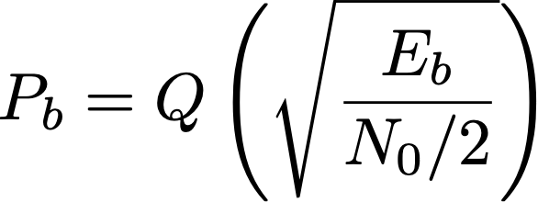

For this project, you will need to:

1. Simulate the bit transmission through the AWGN channel for different SNRs;
2. Write a Monte Carlo program to estimate the probability of error of optimal detector;
3. Compare the results in 2) to the analytical expression given by above formula;
4. Plot the Pb vs. SNR (SNR on x-axis, Pb on y-axis), where both Monte Carlo simulation and theoretical results derived using Q-function should be included.
5. (Graduate students) – derive the above formula.

The code can either be written in C or Matlab.

Deliverables:

A ZIP file containing:

1. Your source code;
2. A plot of Pb vs. SNR, including the Monte Carlo simulation and the theoretical results derived using Q-function;
3. A short report (1-2 pages) in IEEE Transactions format detailing the problem statement, a brief description of the solution, and a discussion on results of the study. Please cite references as needed.